Due to the December 2011 court ruling you may no longer allow the public access to any data that displays a person’s State Payment. NEMRC has made appropriate changes to the Grand List software to allow end users to accommodate that court ruling. These modifications will be available in all of your grand list entities. Below are instructions on how to hide state payments from:
- tax bills and the tax book
- Set up passwords to restrict access for users of your public access terminals
- Vocabulary –
  - Total Tax – The tax due before any State Payments amounts are deducted.
(Grand list value * (all Tax rates + Late filer penalty) = Total Tax
  - Net Tax – The Tax due after State Payment amounts are deducted.
(Total Tax – State Payment) = Net Tax
  - Net Tax Payments – The Net Tax divided by the number of installments your town has
on the tax bills. (Net Tax / # of installments)
Tax Book Options

- Printing and reprinting tax books to hide state payment information:
  - Open the as billed grand list and go to the ‘Reports’ menu and select ‘# 5 Tax Book’. The option to hide the state payment information has always been available. See picture below on the left. There are 2 options circled. ‘Print State Payment Amount’ and ‘Print Net Tax Payments’ when both of these are left unchecked the program will NOT display the State Payment Amount or the Net Tax Payment amounts. See figure on the right. The State Payment and the Net Tax Payment would normally show in the areas circled but are now hidden. It is very important to uncheck both boxes if you are printing this tax book for the public to view. If you only check one of the boxes who ever views the report could figure out someone’s state payment in one of 2 ways.
    - You would display the State payment
    - You would display Net Tax Payments which someone could simply subtract those from the Total Tax.
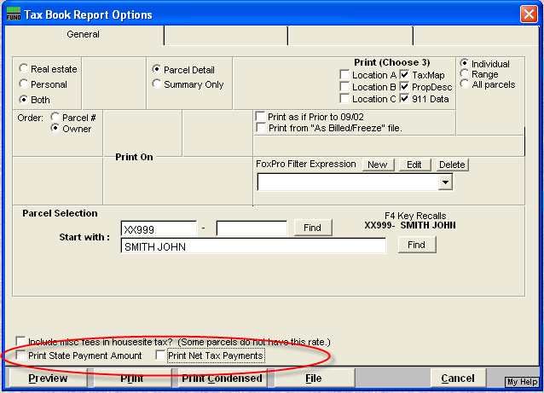
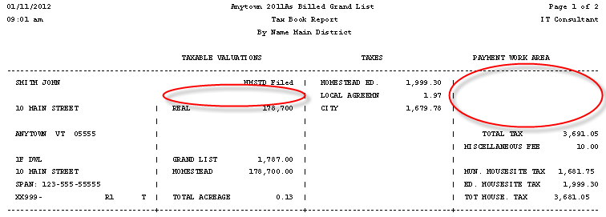

2. Reprinting Tax books to show State Payment information:
b. To reprint a copy of the Tax book for your use, simply make the appropriate selection of ‘State Payment Amount’ and ‘Net Tax Payments’ you desire. See the figures below now both the State payment and the Net Tax Payments are printed on the report.
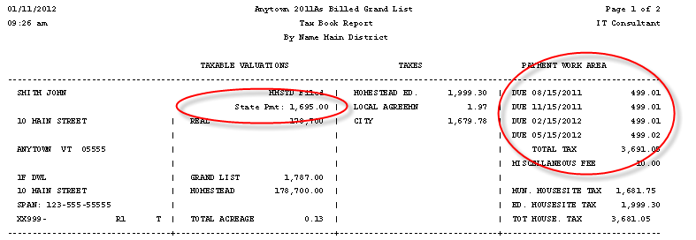
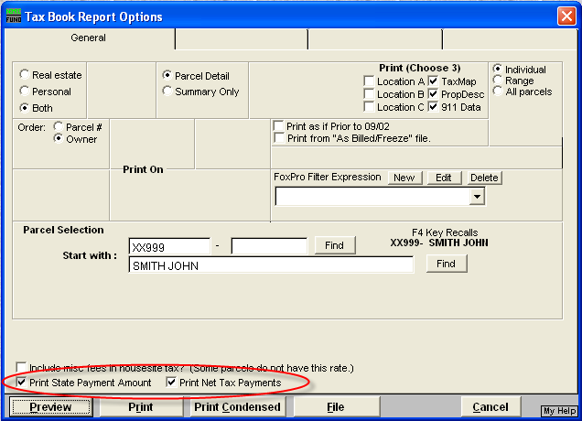

Tax Bill Options

          - Printing and reprinting tax bills to hide or show the state payment information:
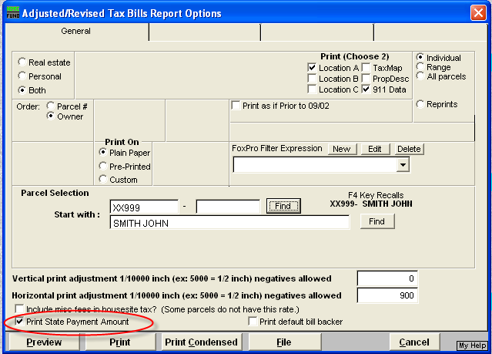
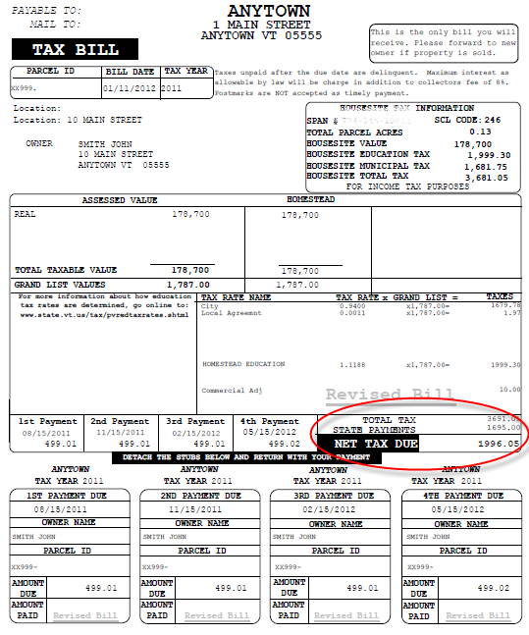
              - Open the as billed grand list and go to the ‘Reports’ menu and select any of the tax bill report options Copy of, Adjusted / Revised, or Late Filers. There is now an option to hide the state payment from printing on the tax bill. See picture below on the left. This box will default to SHOW the State Payment as we do not want someone to inadvertently print and mail all of their tax bills without the State Payment being displayed. So it is very important that you spot check your tax bills before you mail them to insure everything is printing properly. The figure on the right shows you that the tax bill will print as it normally would in the past displaying the State Payment, Net Tax and Net Tax Payments.

        - Printing and reprinting tax bills to hide state payment information:
To hide the State Payments on a tax bill simply uncheck the check box ‘Print State Payment Amount’ as seen in figure below on the left. The tax bill will now only show the ‘Total Tax’ and not show any State Payment information or Installment information. This will apply to all tax bills even if they do not have a State Payment applied to their parcel. This was done so no one can tell who has a State Payment applied to their tax bill versus someone that does not have one applied. Refer to figure of the tax bill on the right.

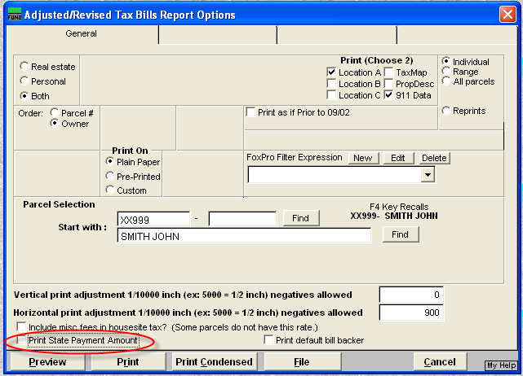
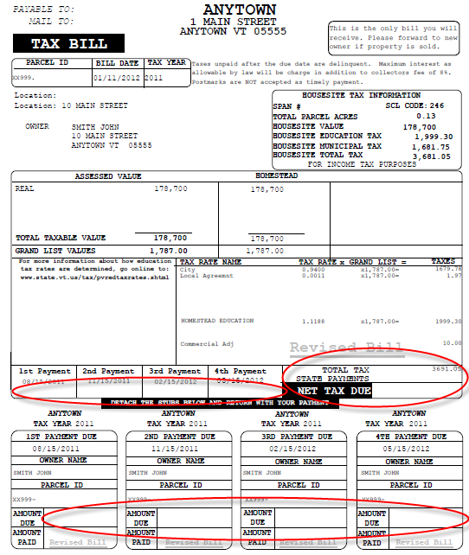

Setting up Public Access Passwords

- If you allow the public or unauthorized Town/City officials access to look at your grand list program then you need to restrict various areas of the program so they can not access State Payment information. NEMRC has gone through the program and established all the areas that should be restricted so you must modify any public access passwords you have created in the past.

IMPORTANT: THIS MUST BE DONE IN EACH GRAND LIST ENTITY!!!! That means every As billed grand list, Working, lodged, or Reappraisal grand list you allow public access.

To restrict access follow the steps below for each of your grand list entities.

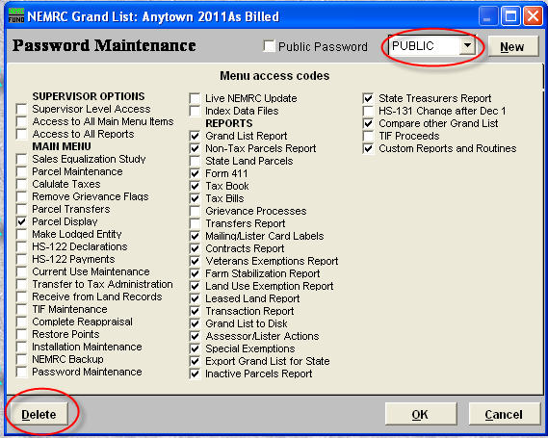
- Open the Grand list program and select an entity. Once on the ‘Main Menu’ select ‘P Password Maintenance’. Click the drop down and select the password you assigned for the “Public” to use when they wanted to look at your grand list. In the figure below you will see the password assigned is “Public”. Then click on the ‘Delete’ button in the lower left corner that will remove this password. Repeat this process for all passwords assigned to any unauthorized Town/City officials that should not have access to State Payment information. Then proceed to the next step.

- Setting up a new ‘Public’ access password for the public to use or for Town/City officials that should not have access to State Payment Information.
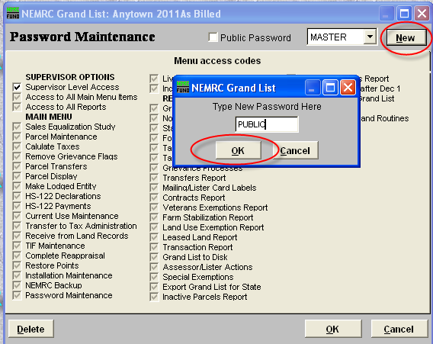
  - Click on the ‘New’ button and type a password in the space provided. Then press the ‘Ok’ button. You can use the same password that you deleted in the previous step. See figure below.

  - You will notice there are not any check marks in any of the ‘Menu access codes’ at this time. As seen in picture on the left. Now place a check in the box labeled ‘Public Access’ at the left of your new password as seen in the picture on the right. You will notice that certain ‘Menu access codes’ are grayed out. These are areas of the program that pertain to the showing of State Payment information. Now it is up to you to select the remaining available areas of the program by placing a check in the box.

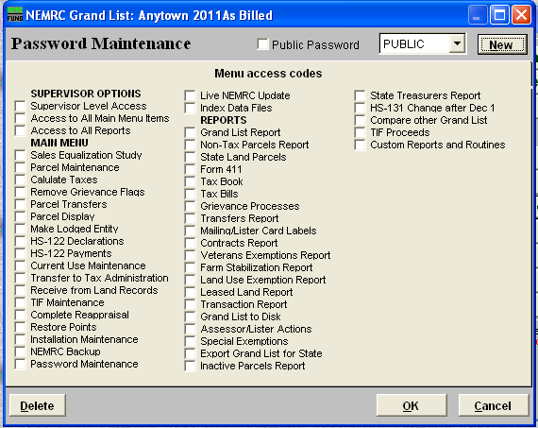
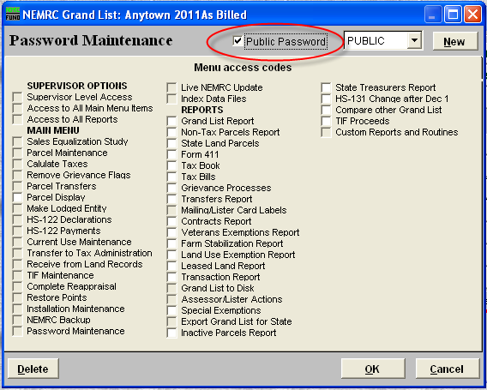

  - When placing a check in the available ‘Menu access codes’ you can allow the public to access the ‘Tax Bills’ and ‘Tax Book’ as we have programmatically turned off the ability to see the ‘State Payment’ or ‘Net Tax Payment’ information. Refer to the tax book illustration on the bottom of page 1 and tax bill illustration on page 3. Also in ‘Parcel Maintenance’ and ‘Parcel Display’ we have removed the ‘Payment/Tax Data’ tab from that screen as well. Below is an example of a ‘Public’ access password in which you can see they have access to the following areas of the program:
    - ‘Main Menu’
      - Parcel Display
    - ‘Reports Menu’

      - Grand List
      - Non tax Parcels
      - State Land Parcels
      - 411
      - Tax book
      - Tax bills
      - Contracts
      - Veterans Exemptions
      - Farm Stabiliztions
      - Land Use Exemptions
      - Leased Land
      - Special Exemptions

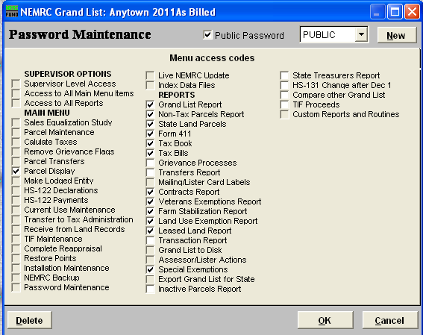

IMPORTANT NOTE ABOUT EXPORTING DATA

If you export data to various people using the ‘H Export data’ feature in the grand list on the ‘Reports Menu’ it is important that you do not export the Tax Payment1, 2, 3, or 4 fields. Simply uncheck those 4 fields and continue with the export process. Those 4 fields will show ‘Net Tax Payment’ amounts in which someone would then be able to figure out the State Payment amount that was applied to a parcel. See figure below. Those fields have been unchecked so they will not be included in the export file.

